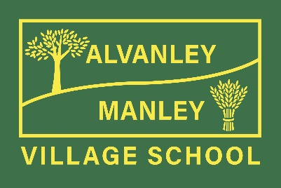
Alvanley Site
Alvanley
Frodsham
Cheshire
WA6 9DD
01244 478021

Tel: 01244 981211

Manley Site
Manley
Frodsham
Cheshire
WA6 9DU
01244 478024

Tel: 01244 981211

Together we nurture, inspire and achieve
Headteacher: Mr V Thapar
E-mail: head@alvanley.cheshire.sch.uk
head@manley.cheshire.sch.uk

Tuesday 3rd January 2023

Re – Knowsley Safari Park Trip

Dear Parents

On Thursday 26th January, Class 1 (Reception) and Class 2 (Years 1 and 2) will be visiting Knowsley Safari Park as part of our Science topic on Animals and Classification.

We will travel by coach, leaving the Manley site just after 9:20am and returning just before home time.

Children will need to be in their school uniform.

Although we will stay on our coach for our main Safari tour, children will need a warm coat and strong footwear that is suitable for our Safari walk. Children will need to take a water bottle and packed lunch with them. If your child is ordering a packed lunch from school, please choose from ham, cheese or tuna and e-mail Mrs Murphy with your selection at admin@alvanley.cheshire.sch.uk

Children do not need to bring a snack, as school will provide this.

During our visit, all children will: take part in a ‘Safari Walk’, observe a ‘Birds of Prey’ flight demonstration, watch a ‘Sea-Lion Show’ and have a guided coach trip through the Safari Park, led by a Ranger.

The cost for this trip will be £17 per child, which includes the cost of the coach and entry to the Safari Park. Please log on to ParentPay by 20th January – any issues please contact school.

As always, we welcome offers of parent support. If you are available to support on this trip please let Mrs Murphy know by emailing her at: - admin@alvanley.cheshire.sch.uk

Thank you for your continued support.

Wendy Edwards
Class 2 Teacher

