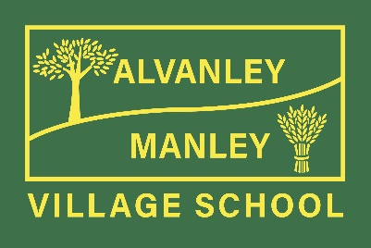
Alvanley Site
Alvanley
Frodsham
Cheshire
WA6 9DD
01244 478021

Tel: 01244 981211

Manley Site
Manley
Frodsham
Cheshire
WA6 9DU
01244 478024

Tel: 01244 981211

Together we nurture, inspire and achieve
Headteacher: Mr V Thapar
E-mail: head@alvanley.cheshire.sch.uk
head@manley.cheshire.sch.uk

8th February 2023

World Book Day - Thursday 2nd March 2023

Dear Parents

This year we are celebrating World Book Day by promoting a love of reading with lots of exciting activities happening across both sites on the day.

This year’s message to children is:

‘We Love to Read!’

We would like your child to come to school on Thursday 2nd March dressed as their favourite BOOK character. Please make sure that their costume is related to a book that they know and that they can talk about, who they are and the story they are from. Costumes can be simple and homemade. Please do not feel pressured into buying a brand-new costume. The most important part is that it reflects your child’s favourite book character. Local libraries are now offering a World Book Day costume exchange programme, or you might like to swap costumes from the past with other families at school.

For activities you can do at home and help with getting your child to read, the World Book Day website has plenty of suggestions. Follow this link to take you to the website:
https://www.worldbookday.com/celebrate-world-book-day/

We look forward to seeing the children’s costumes and hearing all about their favourite characters!

Thank you for your continued support.

Claire Adams
English Leader
Alvanley & Manley Village School

