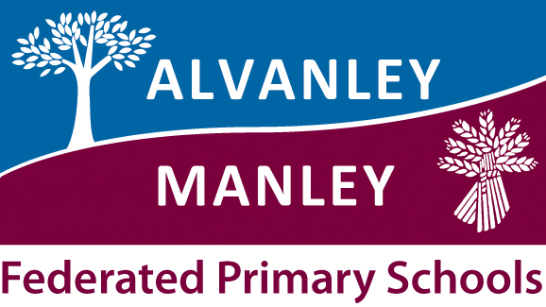
Alvanley Primary School
Alvanley
Frodsham
Cheshire
WA6 9DD
01244 981211

Tel: 01244 981211

Manley Village School
Manley
Frodsham
Cheshire
WA6 9DU
01244 981201

Tel: 01244 981211

Headteacher: Mr V Thapar
E-mail: head@alvanley.cheshire.sch.uk
head@manley.cheshire.sch.uk
_____________________________________________________________________________________________

18th May 2018
Dear Parent/Carer,

Please see below important dates for your diary for the summer term.

Tuesday 6th June Class Three Tempest Afternoon

Class Three will be joining with Manley Village School from 1:30-3:15pm for a singing and props workshop linked to this year’s production of ‘The Tempest’. The workshop will take place at Manley Village School, parents will need to collect children from Manley at 3:15pm.

Wednesday 6th-7th June – Year 1 and 2 Federation Residential

Class One will all be visiting the Catalyst Museum on Wednesday 6th, Reception will come home the same day and Year 1 and 2 will have the opportunity to stay overnight and return to school on Thursday.

Tuesday 12th June – Class Three Water Workshop

Class Three will be welcoming Kingfisher Workshops into school to teach us about the water cycle, water efficiency and water usage on a local and global scale.

Thursday 14th June – Whole School Sports Day

Our annual sports day will be taking place on the field, starting at 1pm and finishing at approximately 3.45pm. The children will take part in a variety of events using a range of athletic techniques and skills. Their individual achievements, as well as a team score, will be recorded. There will also be a selection of races towards the end of the afternoon. In order for a smooth running of the event, we ask for your help to serve refreshments to the children. (No experience is necessary!) If you are willing to help, please let a member of staff know.

There will be a marked area for spectators and for safety reasons we ask that all spectators remain within this. As the events will take place around this area, you will be able to watch your children take part in each activity. Please feel free to bring your own refreshments. All children will require a named drinking bottle, sun hat, sun cream, a tracksuit, blue/black shorts, trainers/pumps and a T-shirt in the colour of their team –

Friday 22nd June – Whole School Photograph

The photographer will be visiting school in the afternoon to take our annual whole school photograph.

Tuesday 26th June – Celebration Afternoon
Parents, Grandparents and Carers are invited to join us for our Celebration Afternoon which will be starting at 1.30pm. You will have the chance to see your child’s work in their classroom and there will also be a Maypole performance, live cooking lessons and much more!

Thursday 28th June – Wildlife Day

Now that our school grounds are looking fantastic, our PTA have kindly funded a day with Cheshire Wildlife Trust for all children in school. We will be exploring our school grounds through a variety of games and activities. Children will need to wear old clothing (including appropriate footwear), waterproof coats and sunhats. Please make sure your child brings a water bottle, wears sun-cream and takes hay fever medication if required as they will be outside for much of the day.

Tuesday 3rd July – Year 3 and 4 Residential

As part of their Science topic, year 3 / 4 will be joining up with Manley children for a federation trip to o Burwardsley for a fun packed overnight stay. They will be enjoy pond dipping and den building amongst the activities planned.

Tuesday 17th / Wednesday 18th July – KS2 Performance

This year our performance will be ‘The Tempest’. Performances will take place as follows:
Tuesday – afternoon and evening
Wednesday – evening only

Friday 19th July – Leavers’ Service

A chance to say goodbye to our 2018 Leavers – bring your tissues!

More details to follow soon as needed, many thanks for your support.

Yours sincerely
Alvanley Staff

