

Friday 10th January 2020

Dear Parent/Carer,

Vara Sports are delighted to announce they have teamed up with Alvanley and Manley Federated Primary Schools, to offer children in Reception - Year 6 a place on our after school clubs for free. We will be delivering exciting and fun after school clubs ran by highly qualified coaches at Alvanley Primary School on Wednesday & Thursday and they will run up until February half term.
After School Clubs 3:15pm-4:15pm (First come, first serve)

Wednesday – Ninja Warrior Challenge- Gymnastics (Limited to 20 places): All years
Starting 15th January

Thursday – Tri-Golf: All years - starting 30th January

How to book a place for your child -
Please fill out the reply slip below. Please ensure your child hands in their reply slip to their teacher or email Mrs Lishman: admin@alvanley.cheshire.sch.uk. You will be notified if your child has secured a place.

Ninja Warrior will start Wednesday 15th January 2020
Tri-Golf will start Thursday 30th January 2020

Any enquiries regarding the clubs: please contact Vara Sports Head Of PE, Mr Fontana on the Vara Sports Mobile - 07808833673 or email Info@varasports.co.uk Also follow Vara Sports on Social Media to keep up to date on news, events and club information - @Varasports Facebook/Twitter/Instagram

----------------------------------------------------------------------------------------------------------------------------------------
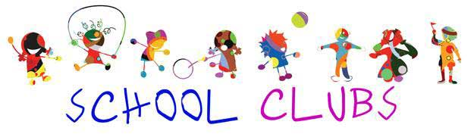

Reply Slip

Child’s name: ___________ __ _____Child’s Class____ ____

I wish my child to take part in (please tick):

Ninja Warrior Challenge – Gymnastics fun (Wednesday 3:15pm - 4:15pm)
Starting Wednesday 15t January 2020

Tri-Golf (Thursday 3:15pm - 4:15pm) Starting Thursday 30th January 2020

Any known medical conditions or special requirements __________________ _____________

Parent/Guardian Signature: ________________ Today’s Date:______________ _________

