Thursday 9 August | New York Times  Latest news and bulletin updates |  |  |  | Issue  #10
Smoke Spills from The Guggenheim  Report by Zac Taylor  Fire engines raced to the scene earlier today as an image of chaos unfolded. It seems the museum had been infiltrated by an anonymous character who was up to no good, there was smoke and panic everywhere.  Luckily, there were no casualties, but who did this...and why? Our reporter on the ground, Bob Brittle, interviewed a witness to the events, Sandra Cook, who was inside the Guggenheim museum when the terrifying drama occurred, Sandra commented:  ‘I was in the Guggenheim talking to my colleague, Gloria, when all of a sudden an ear-piercing explosion ripped through the hallway and my eyes were stinging with the smoke, I couldn't open them. I thought I was blinded!"  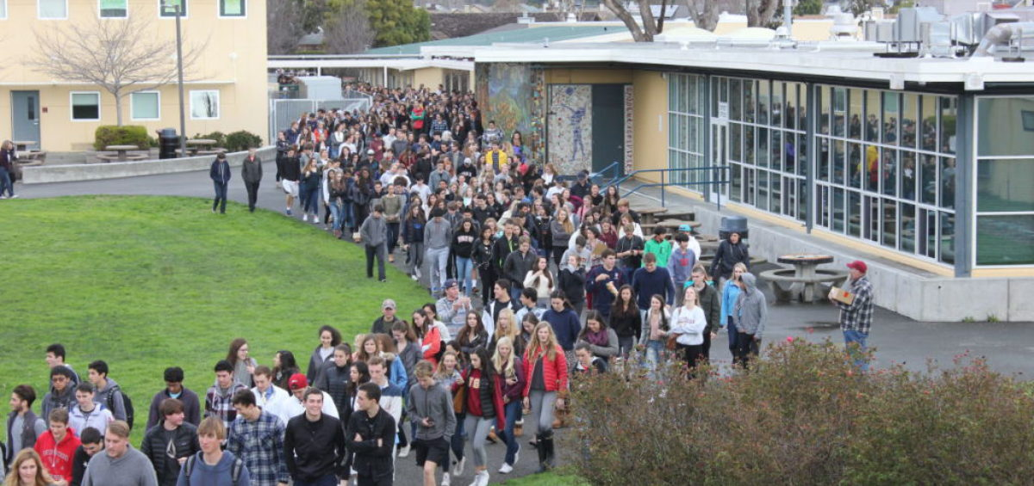  Evacuation in progress - image by Sarah Snapper |  |  | 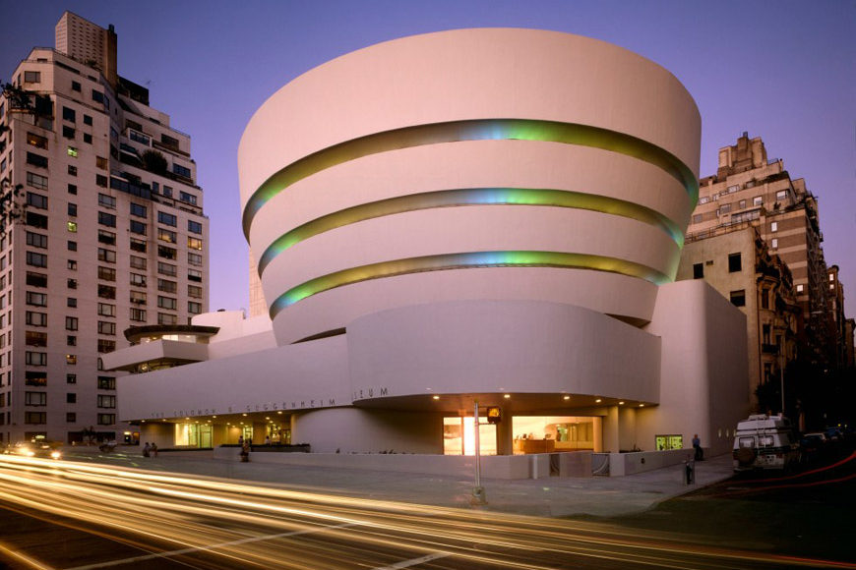
 |  |  | The Guggenheim - Image by Sarah Snapper
All visitors and staff were evacuated including museum staff that were in the process of setting up the latest exciting art exhibition.

At the time of writing this report, the museum remains closed and investigation work is ongoing.

